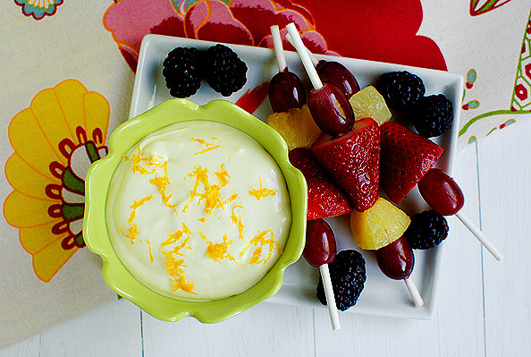
Best Fruit Dip
Ingredients:
7oz Marshmallow Creme
8oz low-fat or whipped cream cheese, softened to room temperature(in class we used whipped berry cream cheese)
2 Tablespoons frozen orange juice concentrate or 1 large orange

Step 1: Soften the Cream Cheese
Make sure you put the cream cheese out to soften to room temperature about one hour before you want to make the dip. This is very important, otherwise you end up with very lumpy dip. (Not that lumps of cream cheese are really a bad thing.)

Step 2: Add Marshmallow Fluff
Add the marshmallow fluff!

Step 3: Add Juice from 1 Orange
-Cut the orange in half and then squeeze the juice from both halves into the bowl. I use my fingers to really squish all the juice out of the orange. Little bits of pulp falling in are a-okay!
-Or Add the 2 Tablespoons of frozen orange juice concentrate

Step 4: Mix!
Grab your hand mixer and blend until fruit dip is smooth.

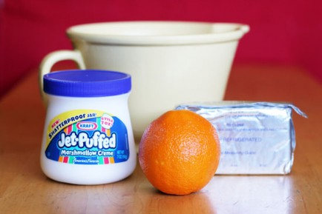
Step 5: EAT!
This fruit dip is delicious with any fruit, so pick your favorites and dig in!
Keep leftover dip refrigerated. Should be good for about 1 week or so...if it lasts that long!

